**Use Case Diagram**

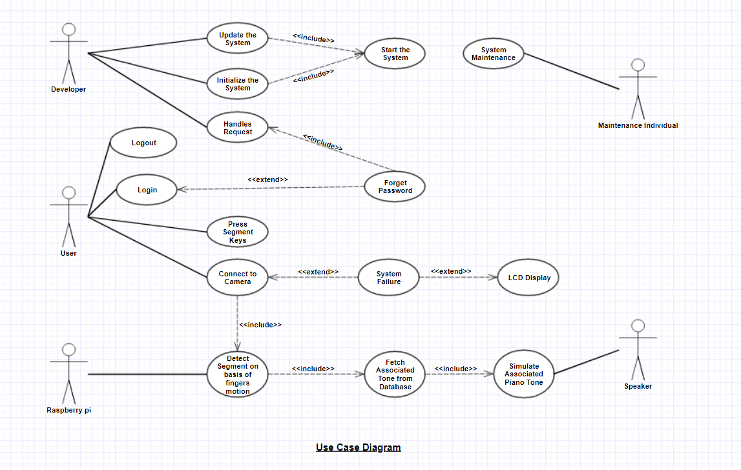

Use Case Template

|  |  |
| --- | --- |
| **Use Case Name:** | **Update the System** |
| **Actor:** | Developer |
| **Description:** | It will update the system as and when required |
| **Preconditions:** | The virtual system must be in proper working condition |
| **Postconditions:** | The system will be updated to its next version |
| **Priority:** | Normal |
| **Frequency of Use:** | Low |
| **Includes:** | Start the System |
| **Extends:** | N/A |

|  |  |
| --- | --- |
| **Use Case Name:** | **Initialize the System** |
| **Actor:** | Developer |
| **Description:** | The system will enter in its working mode |
| **Preconditions:** | N/A |
| **Postconditions:** | This will start the system and will enable the user to use it |
| **Priority:** | Normal |
| **Frequency of Use:** | Low |
| **Includes:** | Start the System |
| **Extends:** | N/A |

|  |  |
| --- | --- |
| **Use Case Name:** | **Handles Request** |
| **Actor:** | Developer |
| **Description:** | The system will handle all types of requests made by the user |
| **Preconditions:** | The user forgets the password or system updation is required |
| **Postconditions:** | The request will be handled successfully |
| **Priority:** | High |
| **Frequency of Use:** | Low |
| **Includes:** | N/A |
| **Extends:** | N/A |

|  |  |
| --- | --- |
| **Use Case Name:** | **Login** |
| **Actor:** | User |
| **Description:** | The user needs to enter his ID so as to use the system |
| **Preconditions:** | N/A |
| **Postconditions:** | The user will use the system on successful login |
| **Priority:** | High |
| **Frequency of Use:** | Normal |
| **Includes:** | N/A |
| **Extends:** | Forget Password |

|  |  |
| --- | --- |
| **Use Case Name:** | **Logout** |
| **Actor:** | User |
| **Description:** | The user |
| **Preconditions:** | The user must be logged in |
| **Postconditions:** | The user will be logged out from the system |
| **Priority:** | Normal |
| **Frequency of Use:** | Normal |
| **Includes:** | N/A |
| **Extends:** | N/A |

|  |  |
| --- | --- |
| **Use Case Name:** | **Press Segment Keys** |
| **Actor:** | User |
| **Description:** | The user will press the segments on the plastic sheet to play associated piano tone |
| **Preconditions:** | The user must be logged in to the system |
| **Postconditions:** | The associated piano tone will be simulated |
| **Priority:** | High |
| **Frequency of Use:** | High |
| **Includes:** | N/A |
| **Extends:** | N/A |

|  |  |
| --- | --- |
| **Use Case Name:** | **Connect to Camera** |
| **Actor:** | User |
| **Description:** | Camera will be mounted above the plastic sheet to detect fingers’ motion |
| **Preconditions:** | The plastic sheet should be placed properly |
| **Postconditions:** | The camera will focus on the plastic sheet and will detect the motion of fingers in real time using Raspberry pi |
| **Priority:** | High |
| **Frequency of Use:** | Normal |
| **Includes:** | Detect Segment on basis of fingers’ motion |
| **Extends:** | System Failure |

|  |  |
| --- | --- |
| **Use Case Name:** | **Detect Segment on basis of fingers’ motion** |
| **Actor:** | Raspberry pi |
| **Description:** | The pressed segment will be determined from the image captured by the camera in real time |
| **Preconditions:** | The camera should be mounted and connected properly |
| **Postconditions:** | The associated tone will be fetched from the database and will be played accordingly |
| **Priority:** | High |
| **Frequency of Use:** | High |
| **Includes:** | Fetch associated tone from database |
| **Extends:** | System Failure |

|  |  |
| --- | --- |
| **Use Case Name:** | **Simulate associated piano tone** |
| **Actor:** | Speaker |
| **Description:** | The piano tone will be played based on the detected segment |
| **Preconditions:** | The segments must be correctly detected |
| **Postconditions:** | N/A |
| **Priority:** | High |
| **Frequency of Use:** | High |
| **Includes:** | N/A |
| **Extends:** | N/A |

|  |  |
| --- | --- |
| **Use Case Name:** | **System Maintenance** |
| **Actor:** | Maintenance Individual |
| **Description:** | To prevent the malfunctioning of the system, periodic maintenance of hardware is required |
| **Preconditions:** | N/A |
| **Postconditions:** | The system functions properly |
| **Priority:** | Normal |
| **Frequency of Use:** | Low |
| **Includes:** | N/A |
| **Extends:** | N/A |

**Tasks and Sub-tasks of the Project**

* Planning
  + Identify Scope
  + Identify functional requirements
  + Identify non-functional requirements
* Synopsis documentation
* Hardware Interfacing
* Development
  + Develop Application
    - Coding
  + Hand off build
  + Testing
  + Fix bugs
* Performance modification
* Final Documentation
* Execution
* Final Report & Project

**Activity Diagram**

**Work Breakdown Structure**

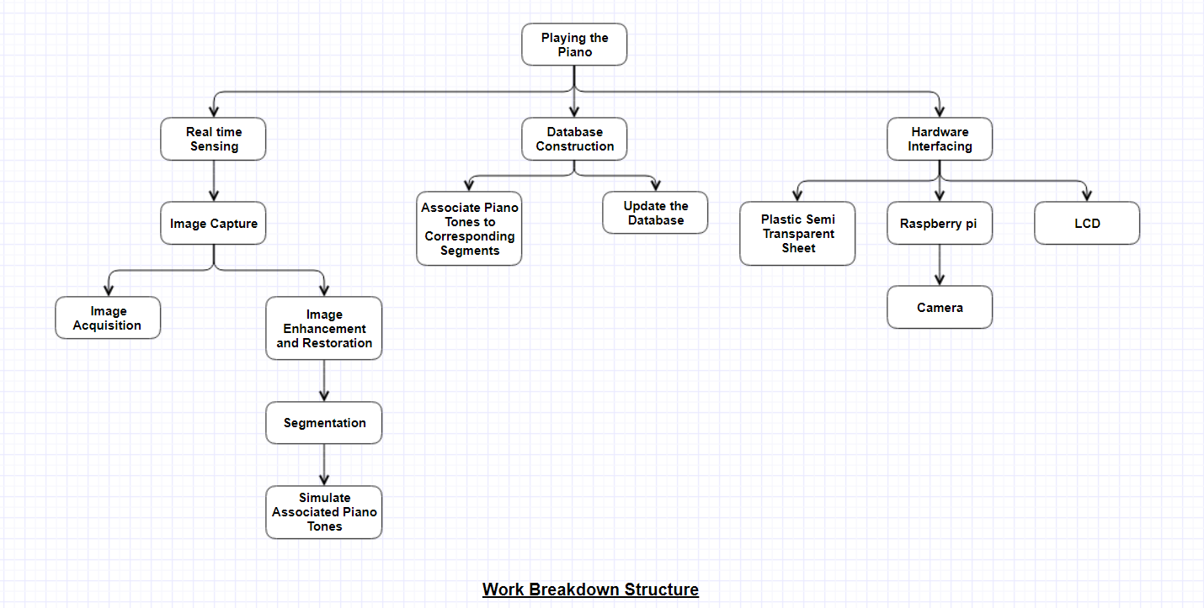

**Scheduling all the tasks in Work Breakdown Structure using Gantt Chart**

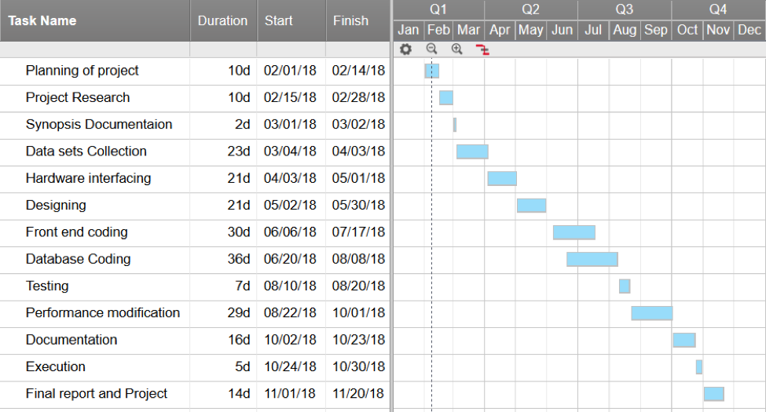

**Functional Requirements**

* The system should do segment detection on the basis of finger’s motion.
* The system should simulate associated piano tone based on the segment detected.
* The system shall allow the user to play music as per his/her requirements.
* The system shall give different sound based on the selected Instrument which is listed in a combo box.
* The system should handle the problem of system failure using a LCD display.
* The size of the transparent sheet should accommodate all the notes of the piano.
* The developer can maintain and update the system by reinstalling the current system.

**Non-Functional Requirements**

* Performance: The response time of the system must be fast and smooth.
* Reliability: No error will encounter while user is using the application.
* Ease of use: A good design interface should be constructed with easy control and friendly user interface.
* Accurate: The system should play the correct piano tone by detecting the segment accurately.